All about ‘this’
Contents
1. The ‘this’ Keyword? 2
Why Use this? 4
Summary 6

The ‘this’ Keyword?
- The ‘this’ pointer(C++)/reference(Java) is a special pointer available inside non-static member functions of a class.
- It points to the object that is currently calling the member function.
#include <iostream>
using namespace std;

class Person {
string name;
public:
Person(string n) {
name = n;
}

void showName() {
cout << "My name is " << this->name << "\n";
}
};
- this->name means "the name which belongs to current object".
- If we do…
Person p1("Alice");
p1.showName(); // prints: My name is Alice

Person p2("Bob");
p2.showName(); // prints: My name is Bob
- Prints…
/*
Address of p1: 0000002095D7F4D8
Address of this: 0000002095D7F4D8
My name is Alice
--------------------------------
Address of p2: 0000002095D7F518
Address of this: 0000002095D7F518
My name is Bob
*/

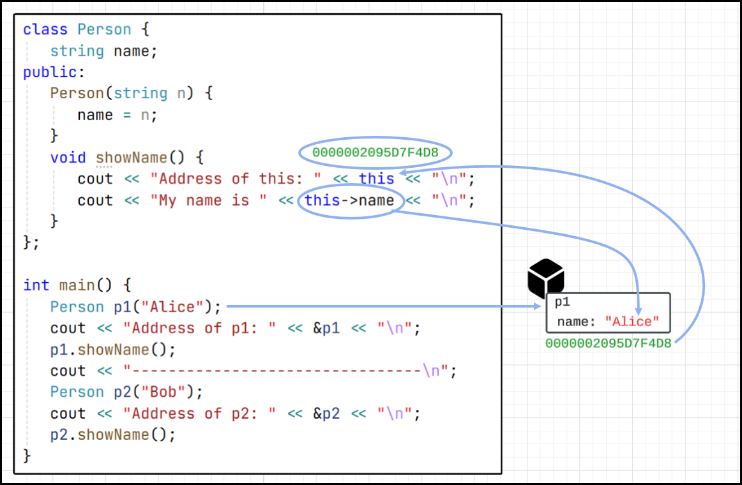
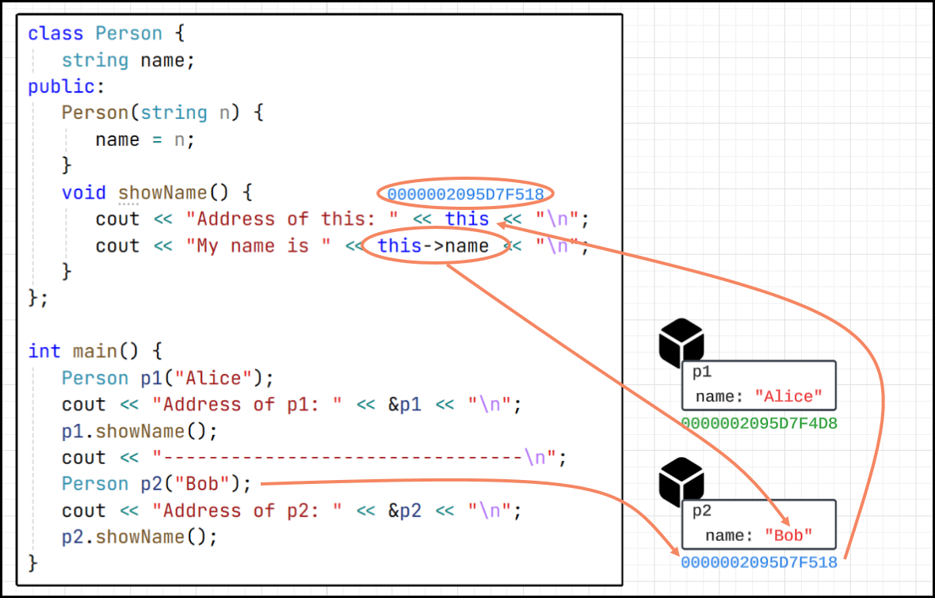

Why Use this?
- To refer to the current object, especially when:
  - You have naming conflicts between parameters and member variables.
  - You need to return the current object from a function.

Naming conflicts:
- When the parameter name is the same as a member variable
class MyClass {  int a;  public:  void setValue(int a) {  a = a;  }  void showValue() {  cout << "Value of a: " << a;  }  };  int main() {  MyClass obj;  obj.setValue(10);  obj.showValue();  }  // Value of a: -858993460 | class MyClass {  int a;  public:  void setValue(int a) {  this->a = a;  }  void showValue() {  cout << "Value of a: " << this->a;  }  };  int main() {  MyClass obj;  obj.setValue(10);  obj.showValue();  }  // Value of a: 10

class Student {  String name;  Student(String name) {  name = name;  }  void show() {  System.out.println("Name: " + name);  }  public static void main(String[] args) {  Student student = new Student("John Doe");  student.show();  }  }  // Output: Name: null | class Student {  String name;  Student(String name) {  this.name = name;  }  void show() {  System.out.println("Name: " + name);  }  public static void main(String[] args) {  Student student = new Student("John Doe");  student.show();  }  }  // Output: Name: John Doe

Return the Current Object from a Function
- The ‘this’ pointer is often used in method chaining
class Counter {
int count = 0;
public:
Counter& increment() {
count++;
return *this;
}

void show() {
cout << "Count: " << count << endl;
}
};

int main() {
Counter c;
Counter d = c.increment();
Counter e = c.increment();
e.show();

Counter().increment().increment().show();
return 0;
}

class Counter {
int count = 0;
Counter increment() {
count++;
return this; // Return current object
}
void show() {
System.out.println("Count: " + count);
}
}
public class Main {
public static void main(String[] args)
{
Counter counter1 = new Counter();
Counter counter2 = counter1.increment();
Counter counter3 = counter2.increment();
counter3.show();

new Counter().increment().increment().show();
}
}

Summary
- The ‘this’ is a pointer(C++)/reference(Java) to the current object.
- It's used inside non-static member functions.
- Helps in disambiguation and advanced techniques like chaining.

